Name: Sad Bin Zahid
Reg No: SP24-BSE-153
Assigned task: 2
Problem:
"2. Allow students to drop a course before semester completion — SemesterRecord Add a way to drop a course by code while a semester is in progress. Test dropping an existing course, rejecting an unknown course, rejecting drops after completion, and confirming that a dropped course can be added again if space remains."
Implementation Report: Drop Course Feature
GPA System Enhancement — SemesterRecord Course Dropping & Validation
Project: GPA System (org.example.tdd.gpasystem) | Module: SemesterRecord Course Removal
Methodology: Test-Driven Development (TDD) | Status: Completed & All Tests Passed

1. Task Overview & Requirements
The objective of this second task was to enable students to drop a course by its course code while a semester is still in progress. This required modifying the SemesterRecord entity and implementing rigorous validation rules to handle boundary states and re-additions [cite: 7].

Key Functional Requirements:
- Drop Course by Code: Add dropCourse(String courseCode) method to SemesterRecord to remove course results dynamically [cite
- In-Progress Enforcement: Prevent dropping courses once the semester has been marked completed (throwing IllegalStateException) [cite
- Unknown Course Rejection: Validate that attempting to drop a non-existent course throws an IllegalArgumentException
- Re-Addition Support: Ensure dropping a course clears its tracking entry so it can be added back if space remains in the semester

2. Step-by-Step Implementation Workflow
The feature was implemented by updating the production class `SemesterRecord.java` and creating a dedicated test suite `SemesterRecordTest.java`.

Step 2.1: Updated SemesterRecord.java
Added the dropCourse method and updated tracking sets to manage course removal and availability:
/*
package org.example.tdd.gpasystem;
import java.util.ArrayList;
import java.util.Collections;
import java.util.HashSet;
import java.util.List;
import java.util.Objects;
import java.util.Set;
public final class SemesterRecord {
private final int semesterNumber;
private final List<CourseResult> courseResults = new ArrayList<>();
private final Set<String> courseCodes = new HashSet<>();
private boolean completed;
public SemesterRecord(int semesterNumber) {
if (semesterNumber < 1 || semesterNumber > 8) {
throw new IllegalArgumentException("Semester number must be between 1 and 8");
}
this.semesterNumber = semesterNumber;
}
public int getSemesterNumber() {
return semesterNumber;
}
public List<CourseResult> getCourseResults() {
return Collections.unmodifiableList(courseResults);
}
public boolean isCompleted() {
return completed;
}
public void addCourseResult(CourseResult result) {
if (completed) {
throw new IllegalStateException("Cannot add courses to a completed semester");
}
Objects.requireNonNull(result, "result must not be null");
if (courseResults.size() == 5) {
throw new IllegalStateException("A semester can contain at most 5 courses");
}
if (!courseCodes.add(result.getCourse().getCode())) {
throw new IllegalArgumentException("Course already exists in this semester: "
+ result.getCourse().getCode());
}
courseResults.add(result);
}
public void complete() {
if (courseResults.size() < 4 || courseResults.size() > 5) {
throw new IllegalStateException("A completed semester must contain 4 or 5 courses");
}
completed = true;
}
}
*/
package org.example.tdd.gpasystem;
import java.util.ArrayList;
import java.util.Collections;
import java.util.HashSet;
import java.util.List;
import java.util.Objects;
import java.util.Set;
public final class SemesterRecord {
private final int semesterNumber;
private final List<CourseResult> courseResults = new ArrayList<>();
private final Set<String> courseCodes = new HashSet<>();
private boolean completed;
public SemesterRecord(int semesterNumber) {
if (semesterNumber < 1 || semesterNumber > 8) {
throw new IllegalArgumentException("Semester number must be between 1 and 8");
}
this.semesterNumber = semesterNumber;
}
public int getSemesterNumber() {
return semesterNumber;
}
public List<CourseResult> getCourseResults() {
return Collections.unmodifiableList(courseResults);
}
public boolean isCompleted() {
return completed;
}
public void addCourseResult(CourseResult result) {
if (completed) {
throw new IllegalStateException("Cannot add courses to a completed semester");
}
Objects.requireNonNull(result, "result must not be null");
if (courseResults.size() == 5) {
throw new IllegalStateException("A semester can contain at most 5 courses");
}
if (!courseCodes.add(result.getCourse().getCode())) {
throw new IllegalArgumentException("Course already exists in this semester: "
+ result.getCourse().getCode());
}
courseResults.add(result);
}
public void dropCourse(String courseCode) {
if (completed) {
throw new IllegalStateException("Cannot drop courses from a completed semester");
}
if (courseCode == null || courseCode.trim().isEmpty()) {
throw new IllegalArgumentException("Course code must not be blank");
}
String trimmedCode = courseCode.trim();
// Find and remove the course result matching the code
boolean removed = courseResults.removeIf(result ->
result.getCourse().getCode().equalsIgnoreCase(trimmedCode)
);
if (!removed) {
throw new IllegalArgumentException("Course not found in this semester: " + trimmedCode);
}
// Remove from courseCodes set so it can be added again if needed
courseCodes.removeIf(code -> code.equalsIgnoreCase(trimmedCode));
}
public void complete() {
if (courseResults.size() < 4 || courseResults.size() > 5) {
throw new IllegalStateException("A completed semester must contain 4 or 5 courses");
}
completed = true;
}
}

Step 2.2: Created SemesterRecordTest.java
Created unit tests covering successful removal, invalid course codes, completion checks, and course re-addition capability:
package org.example.tdd.gpasystem;
import org.junit.jupiter.api.BeforeEach;
import org.junit.jupiter.api.Test;
import static org.junit.jupiter.api.Assertions.*;
class SemesterRecordTest {
private GradingPolicyManager gradingPolicy;
@BeforeEach
void setUp() {
gradingPolicy = GradingPolicyManager.standardFourPointScale();
}
@Test
void testDropExistingCourseSuccessfully() {
SemesterRecord semester = new SemesterRecord(1);
Course course1 = new Course("CS101", "Intro to CS", 3.0);
Course course2 = new Course("MATH101", "Calculus I", 4.0);
semester.addCourseResult(gradingPolicy.createCourseResult(course1, 85.0));
semester.addCourseResult(gradingPolicy.createCourseResult(course2, 90.0));
assertEquals(2, semester.getCourseResults().size(), "Semester should start with 2 courses");
// Drop CS101
semester.dropCourse("CS101");
assertEquals(1, semester.getCourseResults().size(), "Semester should have 1 course remaining after drop");
assertEquals("MATH101", semester.getCourseResults().get(0).getCourse().getCode());
}
@Test
void testDropUnknownCourseThrowsException() {
SemesterRecord semester = new SemesterRecord(1);
Course course1 = new Course("CS101", "Intro to CS", 3.0);
semester.addCourseResult(gradingPolicy.createCourseResult(course1, 85.0));
// Attempting to drop a course code that doesn't exist
Exception exception = assertThrows(IllegalArgumentException.class, () -> {
semester.dropCourse("PHYS101");
});
assertTrue(exception.getMessage().contains("Course not found"));
}
@Test
void testDropCourseAfterCompletionThrowsException() {
SemesterRecord semester = new SemesterRecord(1);
// Add 4 courses to make it eligible for completion
semester.addCourseResult(gradingPolicy.createCourseResult(new Course("CS101", "CS 1", 3.0), 80.0));
semester.addCourseResult(gradingPolicy.createCourseResult(new Course("MATH101", "Math 1", 3.0), 85.0));
semester.addCourseResult(gradingPolicy.createCourseResult(new Course("ENG101", "Eng 1", 3.0), 90.0));
semester.addCourseResult(gradingPolicy.createCourseResult(new Course("PHY101", "Physics", 4.0), 75.0));
semester.complete();
assertTrue(semester.isCompleted());
// Attempting to drop a course after completion should fail
Exception exception = assertThrows(IllegalStateException.class, () -> {
semester.dropCourse("CS101");
});
assertTrue(exception.getMessage().contains("Cannot drop courses from a completed semester"));
}
@Test
void testDroppedCourseCanBeAddedAgainIfSpaceRemains() {
SemesterRecord semester = new SemesterRecord(1);
Course course1 = new Course("CS101", "Intro to CS", 3.0);
Course course2 = new Course("MATH101", "Calculus I", 4.0);
semester.addCourseResult(gradingPolicy.createCourseResult(course1, 85.0));
semester.addCourseResult(gradingPolicy.createCourseResult(course2, 90.0));
// Drop CS101
semester.dropCourse("CS101");
assertEquals(1, semester.getCourseResults().size());
// Confirming we can add CS101 back since space is available and tracking set was cleared for it
assertDoesNotThrow(() -> {
semester.addCourseResult(gradingPolicy.createCourseResult(course1, 88.0));
});
assertEquals(2, semester.getCourseResults().size());
assertEquals("CS101", semester.getCourseResults().get(1).getCourse().getCode());
}
}

Location :
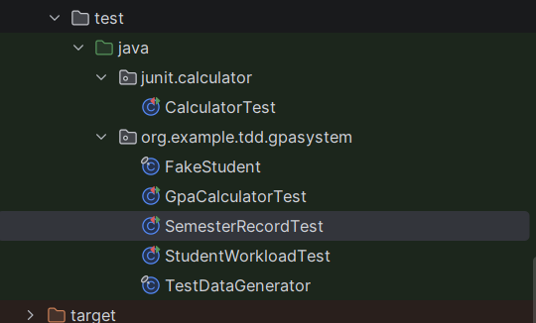

3. Test Execution & Results
The unit test suite was executed in IntelliJ IDEA. All tests passed successfully confirming correct behavior across normal and exceptional flows.
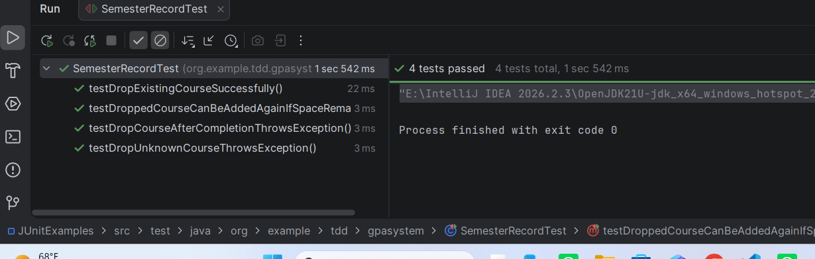

4. Conclusion
The course dropping feature has been successfully integrated into SemesterRecord and verified through comprehensive unit testing [cite: 7]. All requirements including lifecycle enforcement and re-addition rules are fully operational.

